Introduction
It is ideal for a Study Group where individual members of the Study Group cover different topics. The way to use this as part of a Study Group is for the coordinator to split the document into session size elements. Different groups will work at different paces so rather than trying to complete a paper every session, split the papers to match the pace of the group.
Splitting the questions across the group helps with the students workload and encourages debate on the answers.
Asking group members to present their answers in a word document that can be distributed around the group helps the group to cover the whole syllabus.
The questions do not match the style of those in Module papers, rather they are focussed on helping the students to research the topics.

Study parts 5.1 to 5.3 (and 5.13 for the larva) of the syllabus and answer the following questions.

- Write short notes about Robert Evans Snodgrass (R.E.Snodgrass in the syllabus) and Harry Arthur Dade. Focus particularly on their contribution to our knowledge of honey bee biology.
2. Identify the parts labelled A-F on the diagram of the dorsal view of the digestive system of the worker honey bee below.
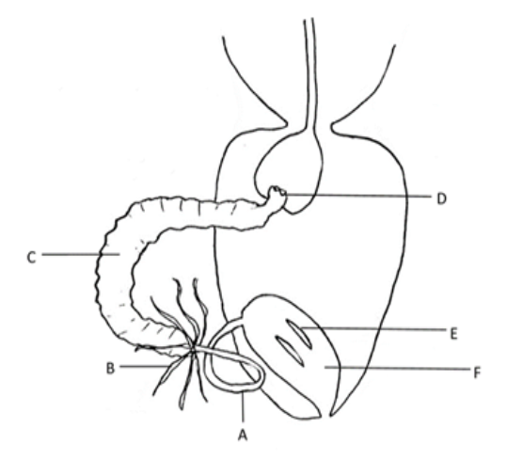
Diagram taken from C. Davis: The Honey Bee Inside Out
3. Define ingestion, digestion, absorption, defecation in the honey bee.
4. In the honey bee the cibarium and pharynx together form a cavity which is sometimes referred to as the ‘mouth’.
(a) What causes the ‘mouth’ to open and close?
(b) Which two glands empty into this cavity and where are they situated?
(c) Give an alternative name for each of these two glands.

5. What is the function of:
- the oesophagus
- the proventriculus
- the ventriculus?
6. What is peristalsis and how is it achieved?
7. Write short notes on the epithelial lining of the ventriculus.
8. (a) What is the peritrophic membrane?
(b) What is the function of this membrane?
9. How are the products of digestion absorbed and assimilated by the honey bee?
10. Describe how the worker bee ingests pollen. Include a description of how the proventriculus works.
11. Describe the process of digestion in the honey bee including the role played by enzymes.
12. What is the crop/honey stomach? Include in your answer its location and function.
13. (a) What are Malpighian tubules? Include in your answer their location and function in the adult honey bee.
(b) Approximately how many Malpighian tubules are found in the adult honey bee?
(c) How many Malpighian tubules are found in a larva?
14. Describe how the excretory system functions in an adult honey bee. Include in your answer the substances excreted.
15. What are rectal pads, where are they found and what is their function?
16. What role does the excretory system play in the water balance in the worker bee?

17. Identify parts A and B on the diagram and describe what is happening at C-F
functions
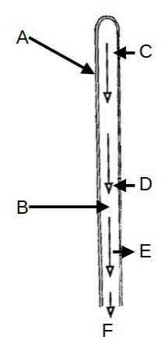
Diagram taken from C. Davis: The Honey Bee Inside Out
18. Identify parts A-F on this diagram of the cross section of Malpighian tubule.
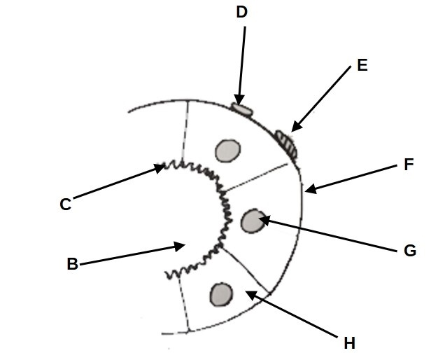
Diagram taken from C. Davis: The Honey Bee Inside Out

Study parts 5.4 and 5.5 of the syllabus and answer the following questions.

1. Identify parts A-D on the diagram of the respiratory system of the worker bee shown below.
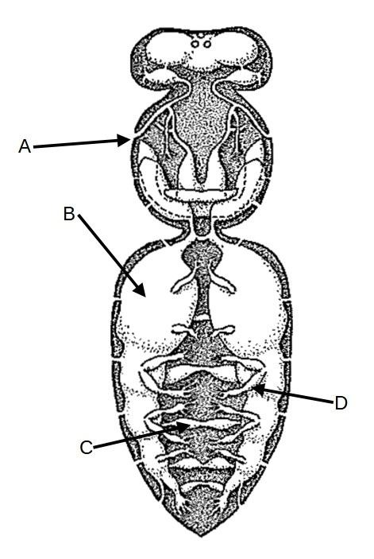
Diagram taken from H.A.Dade: Anatomy and Dissection of the Honey Bee
2. Using a worker honey bee as an example, write short notes on each of the following:
(a) spiracles,
(b) trachea
(c) taenidia
(d) tracheoles
(e) air sacs
3. (a) How many spiracles are there in an adult honey bee?
(b) How do the spiracles operate?
(c) What is different about the first spiracle?
4. (a) Describe the muscular ventilation of the air sacs in a worker bee at rest.
(b) How does this differ if the bee is flying?
5. Where and how does the exchange of respiratory gases take place?
6. Identify parts A-F on the diagram of the circulatory system of an adult honey bee shown below.
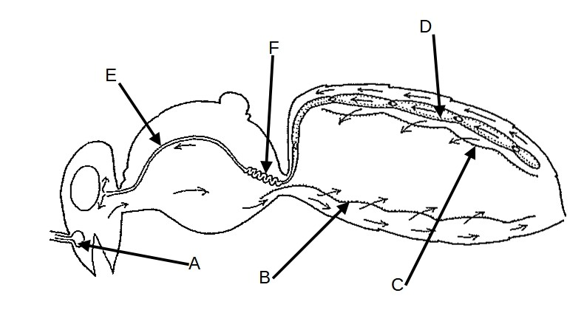
Diagram taken from H.A.Dade: Anatomy and Dissection of the Honey Bee
7. The heart of a honey bee has openings called ostia.
(a) How many ostia are there?
(b) What is the function of the ostia?
8. (a) What are the dorsal and ventral diaphragms?
(b) How do these diaphragms assist in the movement of haemolymph around the body of the honey bee?
9. What is the function of the aorta?
10. (a) Where is the antennal pulsating organ (pulsating vesicle) situated?
(b) What is the function of this organ?
11. Write short notes on the composition and function of the haemolymph.

Study parts 5.6 to 5.9 of the syllabus and answer the following questions.

An exocrine gland secretes a substance to the outside of the organism. The substances secreted sometimes (but not always) act as messengers and the chemicals secreted are sometimes volatile.

- Identify the parts labelled in the diagram below showing the exocrine glands of the worker honey bee.
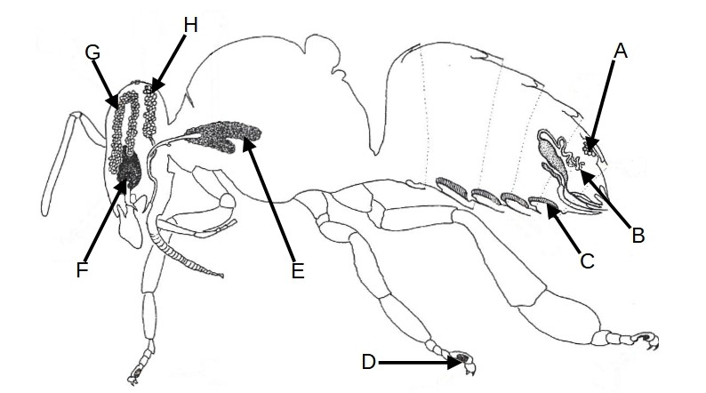
Diagram taken from L. Goodman: Form and Function in the Honey Bee
2. Define the term pheromone.
3. Using a chart like the one below, write short notes on each of the following exocrine glands. Include in your answer the location, function of the gland and whether the gland is found on the worker, queen, drone or larva:
Gland | Larva | Worker | Drone | Queen
hypopharyngeal
mandibular
post genal
Nasonov
poison
Koshevnikov
Dufour
Arnhart
post cerebral
thoracic salivary
wax
Silk
Renner- Baumann (tergite)

4. Give the main secretions of the glands listed above and state whether the secretion is an enzyme, pheromone, food or other. Where the secretions are pheromones name the main constituent parts.
5. Using diagrams/ drawings where appropriate give an outline of the structure of the following glands:
(a) the mandibular glands of the queen,
(b) the hypopharyngeal glands of the worker
(c) the wax glands of the worker
6. Write short notes on the organ of Johnston.
The nervous system of the honey bee consists of three parts:
- the central nervous system (brain, ganglia in various segments, the nerve cord)
- nerves, and
- the sense organs.

7. What is the function of the central nervous system and how do the various parts connect with each other?

8. (a) What is a neuron?
(b) Draw and label a diagram of a typical neuron.
(c) What is the function of a ganglion (pleural is ganglia)?

9. (a) Identify the parts A-F on the diagram of the sensilla placodeum (plate organ) shown below,
(b) give the function of each labelled part.

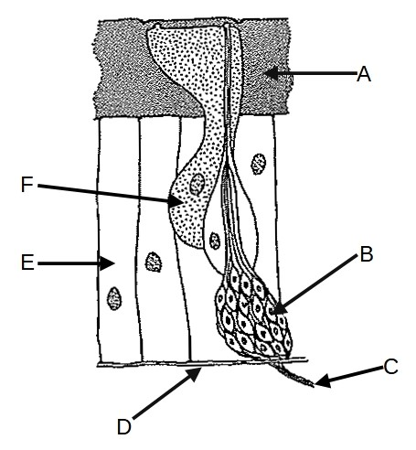
Diagram taken from H.A.Dade: Anatomy and Dissection of the Honey Bee

10. Identify the parts labelled A-H in the diagram of a sensillum trichodeum below

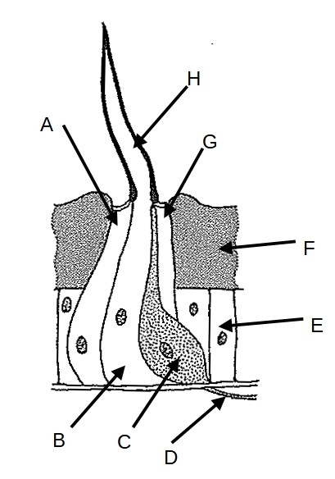
Diagram taken from C. Davis: The Honey Bee Inside Out

11. Give the location, structure and function of:
(a) a sensillum basiliconicum (peg organ) (pl. sensilla basiliconica)
(b) a sensillum coeloconicum (pl. coeloconica)
(c) a sensillum campaniformium (pl.campaniformica)
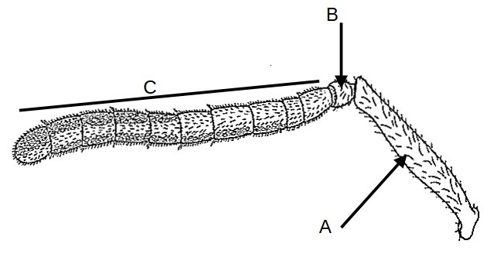
12. This is a diagram of an antenna of a drone.

(a) Identify labels A-C.
(b) Write short notes on the part labelled B

Diagram taken from H.A.Dade: Anatomy and Dissection of the Honey Bee

13. How is the antenna of a drone different from that of a worker?

14. How is this difference of benefit to a drone?

The honey bee has two compound eyes and three simple eyes called ocelli.

The compound eyes are so called because they consist of many different parts called ommatidia (singular is ommatidium).

15. Draw and label a simple diagram of an ommatidium.

16. Having identified each on your diagram, give the function of the following parts:
(a) the corneal lens,
(b) the crystalline cone,
(c) the two primary pigment cells,
(d) the four cone cells,
(e) the retinula cells,
(f) the secondary pigment cells,
(g) the rhabdom

17. (a) Where on the honey bee are the ocelli?
(b) What is the function of the ocelli?
(c) Why are the ocelli on the drone situated in a slightly different position?

Endocrine glands are ductless glands which secrete their products internally within the organism. Their secretions are usually (but not always) hormones which have an effect on the organism itself.

18. For each of the following glands give their position and function within an adult honey bee.
(a) the neurosecretary cells
(b) the corpora allata
(c) the corpora cardiaca, and
(d) the prothoracic glands.

Study parts 5.10 to 5.14 of the syllabus and answer the following questions.

1. Make short notes on the fat body in the adult bee. Concentrate on its composition, location and function.
2. How does the fat body change throughout the life of the bee?
3. What effect does vitellogenin have on the fat body?

The next section of this paper concerns the reproductive system of the queen and the drone and the production of the eggs and spermatozoa (singular spermatozoon). (We usually abbreviate spermatozoa to sperm). You will need to be familiar with the diagrams shown and be able to label them.

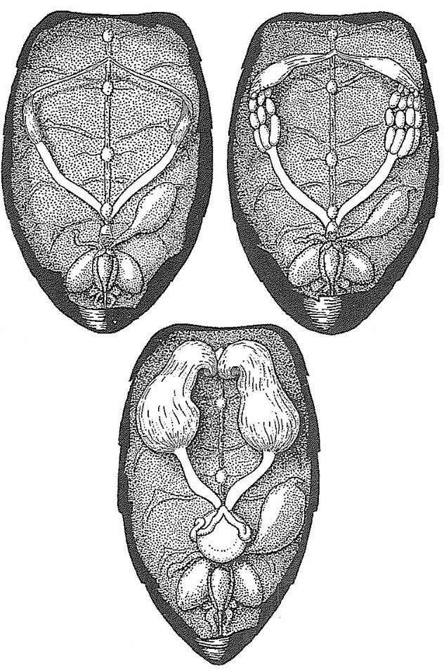

The diagram to the left shows the incomplete reproductive system of a worker bee. Next to it on the right is a laying worker with partially developed ovaries.
The bottom of the three diagrams shows a virgin queen. Note the size of the ovaries in each diagram.

Diagrams taken from H.A.Dade: Anatomy and Dissection of the Honey Bee

4. Identify A-H on the diagram of the mated queen below. Note how the ovaries have now increased in size.

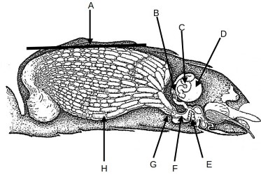
Diagrams taken from H.A.Dade: Anatomy and Dissection of the Honey Bee

5. Considering a mated queen make short notes on:
(a) her ovaries
(b) the oviducts
(c) the vagina
(d) the bursa copulatrix
(e) the spermatheca

The diagram below shows the reproductive organs of a drone.
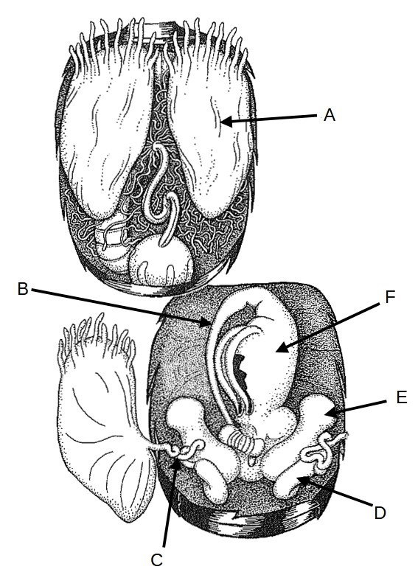
6. Identify the parts labelled A-F

7. What is the likely age of this drone?

8. Make short notes on the function of each labelled part in the diagram.

Diagram taken from H.A.Dade: Anatomy and Dissection of the Honey Bee

The diagram below shows the reproductive organs of a drone as they would be dissected. Note how some parts have changed/developed.

9. Label the parts marked A -H

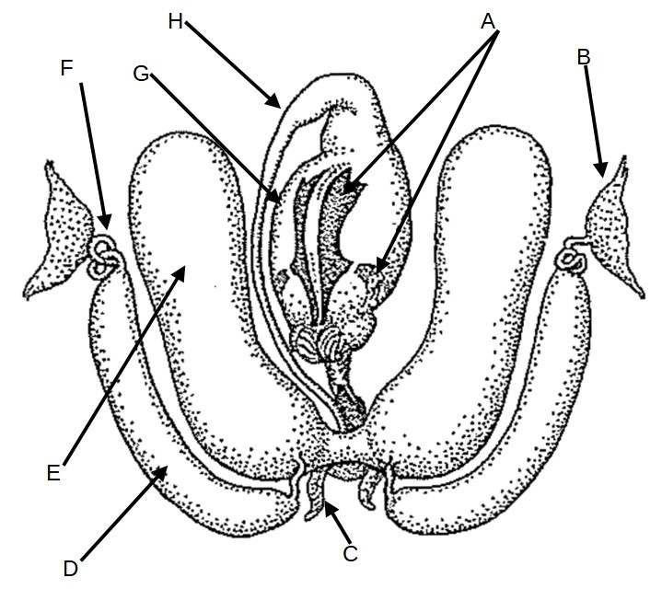
Diagram taken from H.A.Dade: Anatomy and Dissection of the Honey Bee
10. What role does each part play in mating?
The diagram shows the everted endophallus, ie. the male copulatory organ as it is during mating.
11. Label the parts marked A-D and note how their position has changed since the previous diagram.
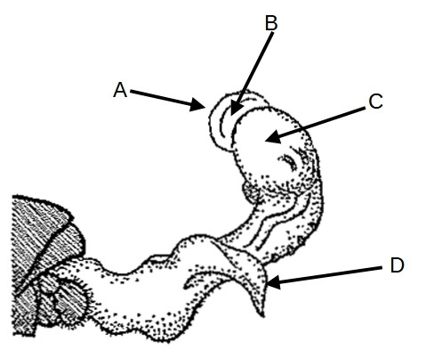
Diagram taken from H.A.Dade: Anatomy and Dissection of the Honey Bee
12. Using simple diagrams describe in detail:
(a) the production of eggs in the ovarioles of a queen,
(b) the production of spermatozoa.
13. Where are the spermatozoa stored in:
(a) the drone,
(b) the queen?
14. Describe, with drawings where appropriate, the structure and development of an egg. Include in your answer the role of the:
- chorion,
- vitelline membrane,
- cytoplasm,
- yolk,
- blastoderm,
- germ band.
15. In the developing embryo what is
(a) the endoderm,
(b) the mesoderm,
(c) the ectoderm?
16. What does ‘invagination’ mean in the developing embryo?
In both female castes and in the drone the larva emerges from the egg after three days. There are several stages in the development of the embryo.
17. List the stages of development of the embryo in the order in which they occur. Start with the initial stage which is cleavage and finish with eclosion.
18. Briefly describe each stage.
19. What is the purpose of the spinneret?
20. (a) At what stage in its development does the larva defecate?
(b) Why is defecation delayed until this time?
21. Name the parts A-H on the diagram of a drone larva shown below.
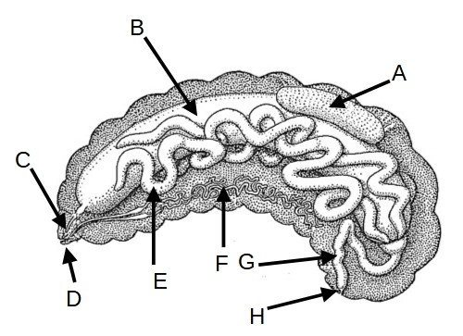
Diagram taken from H.A.Dade: Anatomy and Dissection of the Honey Bee
22. You have just labelled eight parts of the drone larva. Briefly give the function of each of the parts.
23. What is the difference between a larva, a prepupa (propupa) and the pupa?
24. How many times does a honey bee moult before it emerges as an adult?
25. What is metamorphosis?
26. Define:
(a) ecdysis,
(b) apolysis.

Study parts 5.15 to 5.17 of the syllabus and answer the following questions.

There are two sexes of the honey bee; males (which we call drones), and females. There are two castes of females; the workers (incomplete females that cannot mate) and queens.
When the queen lays a fertilised egg, it has the potential to be a worker or a queen. Larvae that are destined to be queens are fed a different diet to the larvae destined to be workers.
1. What is the difference between brood food and royal jelly?
2. At what age must the larva be fed royal jelly if it is to become a queen?
3. What effect does feeding royal jelly have on the corpora allata of the developing larva?
4. How does the larval food determine the caste?
Look back at the diagram of the reproductive systems of a normal worker and laying worker that was in paper four.
5. Outline the structural differences between laying workers and normal workers.
6. Which pheromones normally suppress the development of a worker’s ovaries? (NB. It is not just the queen’s pheromones)?
7. How do some laying workers become physiologically different from their nest mates?
8. Using a chart or table itemise the differences between summer worker bees and winter worker bees?
9. Comment on the role of the fat body in the winter worker bee.
10. What is vitellogenin?
11. What role does vitellogenin play in the development of winter bees?

Study parts 5.18 to 5.23 of the syllabus and answer the following questions.
The cuticle (exocuticle) of the honey bee has several layers and several functions.
- Identify A- F on the diagram below
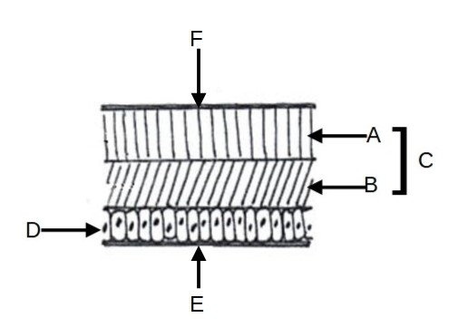
Diagram taken from C. Davis: The Honey Bee Inside Out
2.. List the functions of the cuticle in the adult bee.
3. Describe the structure of the larval cuticle and explain how and why it differs from that of the adult bee.
4. In the developing bee which linings in the body are formed by invagination of the cuticle?
6. Using a table similar to the one below, list at least six external, anatomical differences between a worker, a queen and a drone.

Anatomical feature | Worker | Queen | Drone

7. Identify parts A- L on the diagram of the mouthparts of a worker bee shown below.
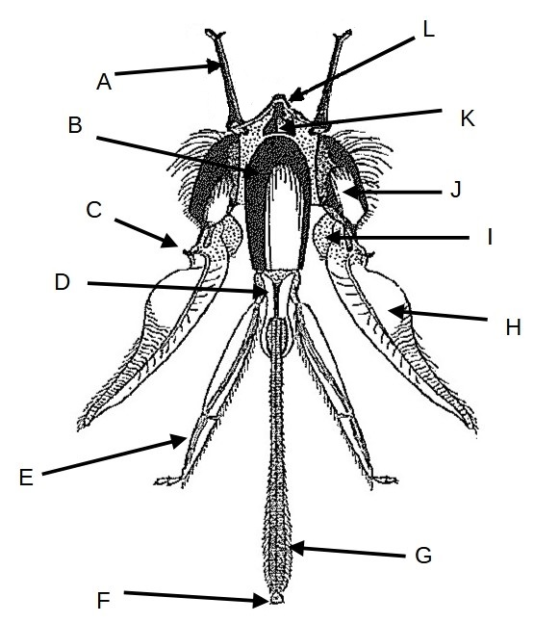
Diagram taken from H.A.Dade: Anatomy and Dissection of the Honey bee
8. Give the function of each labelled part.
This diagram shows the mandibles of :
A: a worker bee B: a queen bee C: a drone
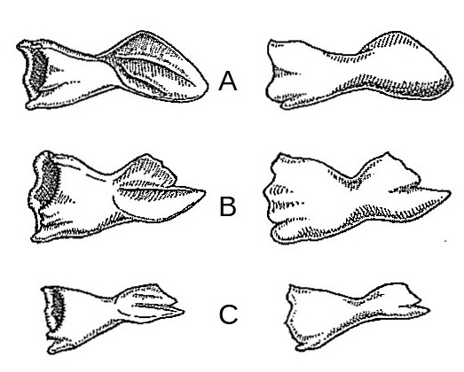
Diagram taken from H.A.Dade: Anatomy and Dissection of the Honey bee)
9. Why are the mandibles of the worker bee large and spoon shaped?
10. Why are the mandibles of the queen sharp and pointed?
11. Why are a drone’s mandibles smaller than those of the queen and worker?
Honey bees have three pairs of legs. The front legs and the hind legs have special adaptions, some of which do not appear in the queen or the drone.
The diagrams below show the legs of a worker bee.
- 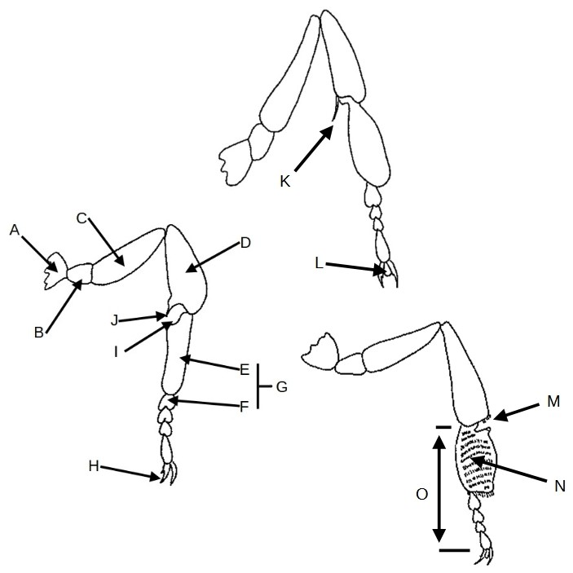
Diagrams taken from C. Davis: The Honey Bee Inside Out

12 (a). Identify each leg as front, middle or hind, and
(b) Identify the parts indicated on each leg.
13. Describe the function and action of the part labelled I
14. (a) L is part of a structure. Name the structure and describe the role played by L.
(b) Explain how L is used by the honey bee.
15. (a) Explain the location, structure and function of the corbiculae
(b) Describe the elements of M
(c) M, N and the corbicula work together. Explain how.
16. How are the forewings and hindwings of a bee attached to each other during flight?
The dorsoventral muscles of the wings of a honey bee are also sometimes called elevator muscles. The longitudinal muscles of the wings are sometimes called depressor muscles. Both are indirect flight muscles. The bee also has direct flight muscles.
17. Why are the flight muscles called ‘indirect’?
18. Explain how the dorsoventral and longitudinal flight muscles cause the wings to move.
19. Write short notes on the direct flight muscles to include their location, how they operate and what exactly they control.
20. Identify parts A-J in the diagram of the sting of a worker bee
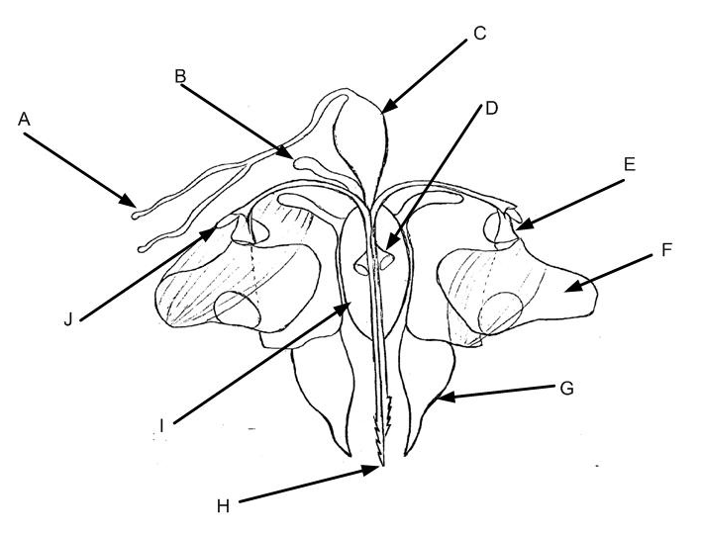
Diagram taken from H.A.Dade: Anatomy and Dissection of the Honey Bee
The sting of a worker honey bee detaches with the associated ganglion when she stings a mammal.
19. Explain how the sting mechanism of a worker honey bee operates.
20. Why does the sting of a worker bee not retract when the bee pulls away.
21. What is the significance of the ganglion remaining attached to the sting mechanism when the sting of a worker becomes detached from her?
22. (a) How does the sting of a queen differ from that of a worker?
(b) Give reasons why the queen’s sting is different.
23. Describe the elements of the exoskeleton of the thorax of the adult bee.
24. How does the structure of the abdomen differ from that of the thorax?
25. Give the name and location of the first abdominal segment.
26. How are segments joined together in the abdomen and how does the bee flex the abdomen to move independently of the thorax?

